COMBINATIONAL ELECTRONIC CODE LOCK

**PROJECT REPORT**

**SUBMITTED BY:**

**KOMMANABOINA PRAMOD - 107108060**

**VANGAPANDU SRI VIJAY – 107108078**

**SAMBHAV R JAIN - 107108103**

AIM:

To construct an electronic code locking circuit for domestic purpose.

ABSTRACT:

1. The portability of a circuit depends on the fact that it can be operated on both a.c. mains as well as on d.c. supply.
2. In the absence of d.c. source, a bridge rectifier (diodes), followed by a filter stage (capacitor) is employed.
3. The control circuit (coil) of the relay is the load at the collector terminal of the transistor.
4. Only one possible combination of switches would drive the transistor into saturation, thus energizing the relay coil.
5. Use of the relay is essential here, to unlock the circuit when energized, thereby completing a closed path.
6. This concept can be applied in child-locking at homes, electronic locking of computers, protection against theft of electricity etc.

APPARATUS REQUIRED:

|  |  |  |  |  |
| --- | --- | --- | --- | --- |
| S.NO. | NAME | | TYPE | QUANTITY |
| 1 | | Transformer | 230-6V | 1 |
| 2 | | Diode (Rectifier) | 1N4007 | 4 |
| 3 | | Diode (Free wheel) | 1N4007 | 1 |
| 4 | | Resistor | 2.2 kΩ | 1 |
|  | |  | 100 kΩ | 1 |
|  | |  | 1kΩ | 1 |
| 5 | | Capacitor | 100 µF, 25V | 1 |
| 6 | | Transistor | 2N2222 (npn) | 1 |
| 7 | | Relay | 6V, 200 Ω (SPST) | 1 |
| 8 | | Switch | SPST | 6 |

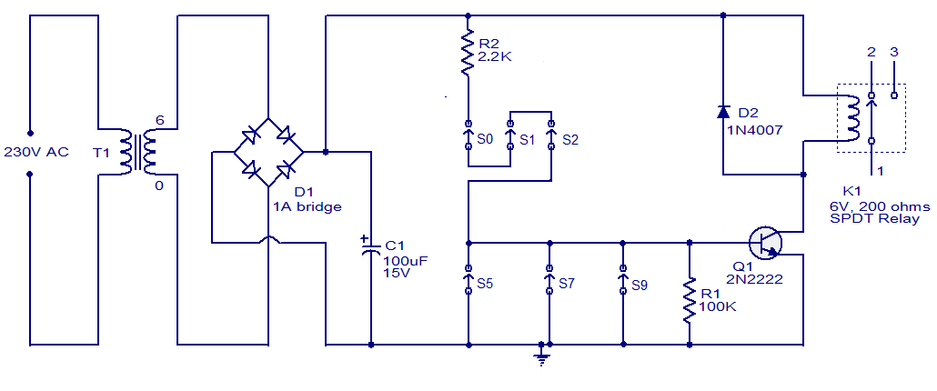CIRCUIT DIAGRAM:

WORKING:

* Using a step-down transformer, 230 V a.c. voltage is stepped down to 6 V a.c. After adding a bridge-rectifier stage, using four diodes connected back-to-back as shown above, a pulsating waveform is obtained. This needs to be filtered, hence is fed through a capacitor stage. The output from the filtering stage is d.c. with minor ripples, which would not affect the performance of this circuit
* An npn transistor is employed with proper biasing circuits, and with the emitter terminal grounded (common-emitter mode)
* Three switches are arranged in series between the base of this transistor and the positive supply rail, through a current limiting resistor, R2
* The other three switches are placed parallel to the resistor, R1 between base of transistor and ground
* When a.c. supply is switched on, the transistor is driven into saturation only if switches S0, S1, S2 are ON and S5, S7, S9 are OFF, simultaneously
* If any of the switches (i.e. S0, S1 and S2) are OFF, then the emitter-base junction would not get sufficient forward bias to drive to saturation
* If any of the switches (i.e. S5, S7 and S9) are ON, then the base would be shorted to the ground, which again turns the transistor OFF
* Hence only one possible combination of switches would yield the desired bias at the transistor junctions

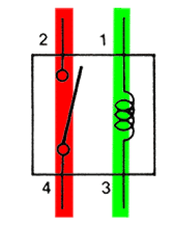

RELAYS:

Relay is a remote controlled electrical switch that is controlled by another switch. They allow a small current flow circuit (control circuit) to control a higher current circuit (load circuit).

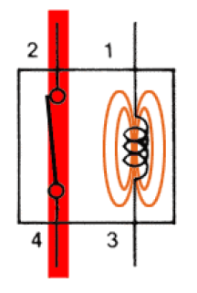

Current flowing through the control circuit coil creates a small magnetic field which causes the switch to close. This switch is a part of the load circuit, to which an electric circuit may be connected. Thus the relay is energized now.

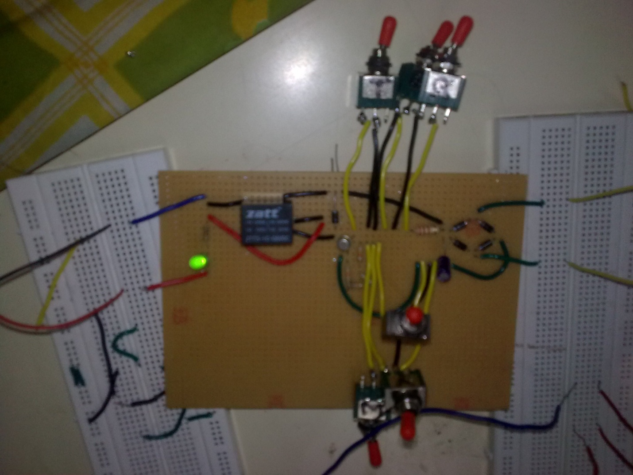

SNAPSHOT OF THE UNLOCKED CIRCUIT:

APPLICATIONS IN REAL WORLD PROBLEMS:

1. Mechanical switches cannot be isolated from kids, however a secret electronic child lock would serve the purpose
2. This circuit has no electrical link between the control circuit and the load circuit. Hence electrical isolation is achieved
3. Theft of electricity is a very common issue in real world. However, using this simple circuit, such possibilities can be locked
4. Electric vehicles are an emerging trend nowadays, to reduce pollution levels in the atmosphere and to eliminate the usage of fossil-fuels. This circuit can very well be used as an electronic key for such battery operated vehicles

RESULTS:

Hence an electronic code locking circuit is constructed and is applied to a simple resistor-LED circuit.